The Port Authority Bus Project: Individual Submission.

- Forecast passenger traffic (2026–2030): Outcome, codes and interpretation.
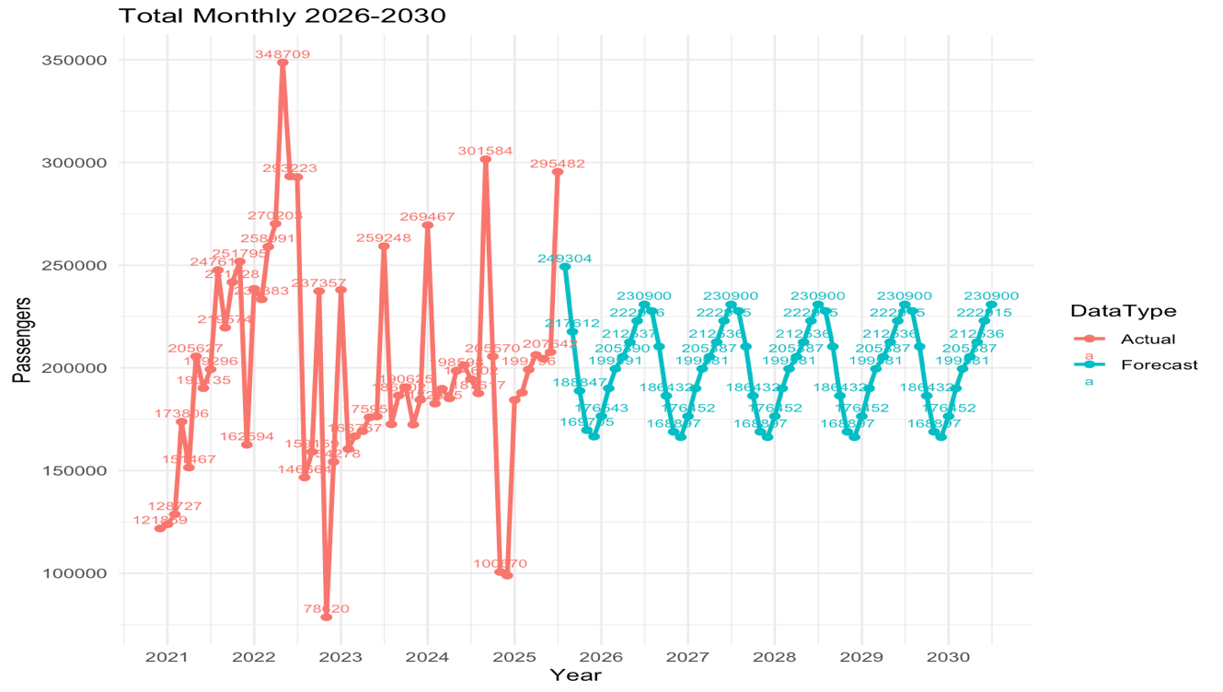

- CODES:
# 1. Aggregate to monthly total passengers (terminal-level)
monthly_totals <- pabt_actual %>%
mutate (YearMonth = floor_date (START_DATE, "month")) %>%
group_by (YearMonth) %>%
summarise (Total_Passengers = sum (PASSENGERS, na.rm = TRUE)) %>%
ungroup ()
# 2. Convert to time series (monthly frequency)
start_year <- year(min(monthly_totals$YearMonth))
start_month <- month(min(monthly_totals$YearMonth))
ts_passengers <- ts (monthly_totals$Total_Passengers,
start = c (start_year, start_month),
frequency = 12)
# 3. Fit ARIMA model
fit_arima <- auto. arima(ts_passengers)
# 4. Forecast until Dec 2030
last_month <- max(monthly_totals$YearMonth)
future_end <- as. Date("2030-12-01")
# Number of months to forecast (from month AFTER last_month to Dec 2030)
h <- length (seq(from = last_month %m+% months(1),
to = future_end,
by = "month"))
fc_arima <- forecast(fit_arima, h = h)
# 5. Build forecast dataframe with dates
forecast_df <- tibble(YearMonth = seq(from = last_month %m+% months(1),
by = "month",
length.out = h),
Forecast_Passengers = as.numeric(fc_arima$mean)
)
# 6. Combine Actual + Forecast for plotting with data labels
combined_df <- monthly_totals %>%
select(YearMonth, Total_Passengers) %>%
mutate(DataType = "Actual") %>%
bind_rows(
forecast_df %>%
rename(Total_Passengers = Forecast_Passengers) %>%
mutate(DataType = "Forecast")
)
# 7. Accuracy of ARIMA model
arima_accuracy <- accuracy(fc_arima)
print(arima_accuracy)
# 8. Plot with years on x-axis and number labels
library(ggplot2)
ggplot(combined_df,
aes(x = YearMonth,
y = Total_Passengers,
color = DataType,
group = DataType)) +
geom_line() +
geom_point() +
geom_text(aes(label = round(Total_Passengers, 0)),
vjust = -0.5,
size = 3,
show.legend = FALSE) +
scale_x_date(date_breaks = "1 year",
date_labels = "%Y") +
labs(title = "Monthly Total Passengers: Actuals & ARIMA Forecast till 2030",
x = "Year",
y = "Passengers") +
theme_minimal()

- INTERPRETATION: From 2021–2025, actual monthly passengers fluctuate widely, ranging roughly from ~80,000 to over 340,000, showing high volatility. From 2026–2030, the forecast stabilizes with a clear seasonal pattern, typically ranging between ~170,000 and ~230,000 passengers per month. Overall, demand is expected to normalize with no extreme spikes or drops.

- Identify key factors: Outcome, codes and interpretation.

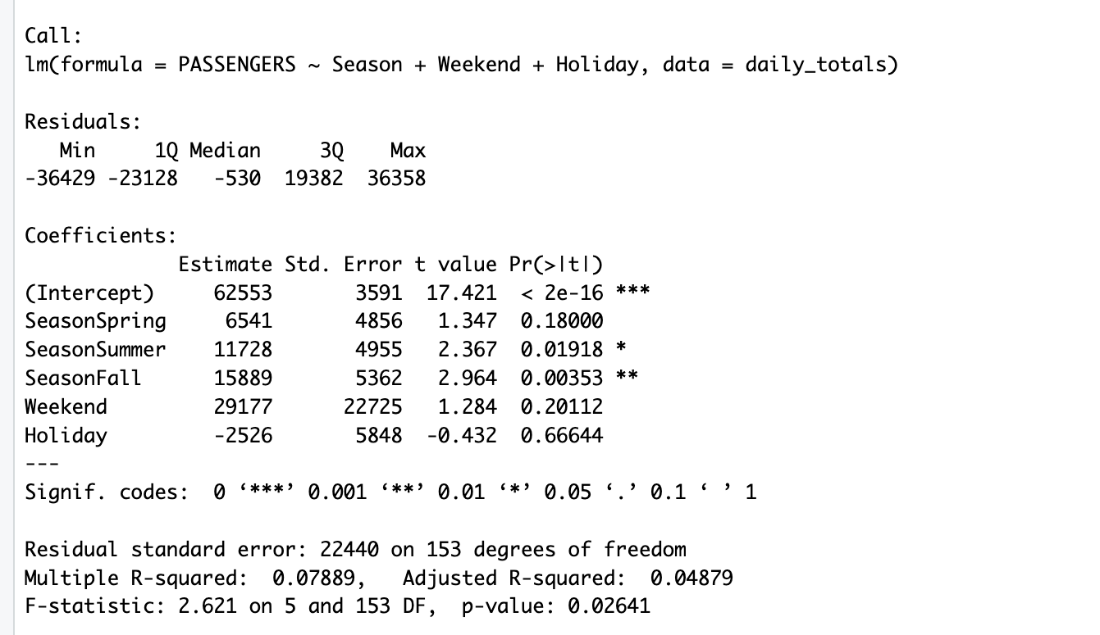

- CODES:
# 1. Aggregate to daily totals across all CARRIER
daily_totals <- pabt_actual %>%
group_by(START_DATE) %>%
summarise(PASSENGERS = sum(PASSENGERS, na.rm = TRUE)) %>%
ungroup()
# 2. Create Season, Weekend, Holiday variables
daily_totals <- daily_totals %>%
mutate(
Year = year(START_DATE),
Month = month(START_DATE),
Weekday = wday(START_DATE, label = TRUE, abbr = TRUE)
# Weekend indicator
Weekend = if_else(Weekday %in% c("Sat", "Sun"), 1, 0),
# Simple meteorological seasons
Season = case_when(
Month %in% c(12, 1, 2) ~ "Winter",
Month %in% c(3, 4, 5) ~ "Spring",
Month %in% c(6, 7, 8) ~ "Summer",
TRUE ~ "Fall"))
# 3. US holidays (approx) using timeDate (NYSE calendar as proxy)
us_holidays <- holidayNYSE(unique(daily_totals$Year))
us_holidays <- as.Date(us_holidays)
daily_totals <- daily_totals %>%
mutate(
Holiday = if_else(START_DATE %in% us_holidays, 1, 0),
Season = factor(Season,
levels = c("Winter", "Spring", "Summer", "Fall")) )
# 4. Linear model: daily PASSENGERS ~ Season + Weekend + Holiday
model_season <- lm(PASSENGERS ~ Season + Weekend + Holiday,
data = daily_totals)
summary(model_season)

- INTERPRETATION: On an average weekday in the reference season, there are about 62,500 passengers per day. Passenger numbers are higher in summer (~+11,700) and fall (~+15,900), while spring, weekends, and holidays do not show a clear effect. Overall, the model finds some seasonal impact, but it explains only a small part (about 8%) of the changes in passengers.

- Carrier-level passenger forecasts: Outcome, codes and interpretation.
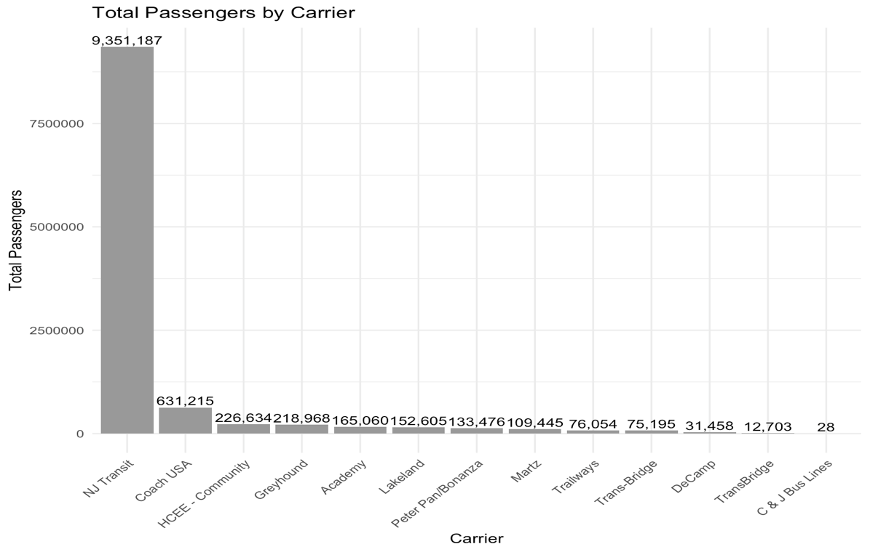
ACTUAL
- CODES:
data <- data %>%
mutate(
YearMonth = as.Date(paste(Year, Month, "01", sep="-")))
# 1. Monthly passengers per CARRIER
carrier_monthly <- pabt_actual %>%
mutate(YearMonth = floor_date(START_DATE, "month")) %>%
group_by(CARRIER, YearMonth) %>%
summarise(PASSENGERS = sum(PASSENGERS, na.rm = TRUE)) %>%
ungroup()
# 2. Nest by CARRIER
carrier_nested <- carrier_monthly %>%
group_by(CARRIER) %>%
nest()
# 3. Build ARIMA model and forecast for each CARRIER till 2030
carrier_models <- carrier_nested %>%
mutate(
# Convert each carrier’s data to a ts object
ts_data = map(data, ~{
ym <- .x$YearMonth
ts(.x$PASSENGERS,
start = c(year(min(ym)), month(min(ym))),
frequency = 12)}),
# Fit ARIMA
arima_fit = map(ts_data, auto.arima)

- INTERPRETATION: NJ Transit dominates passenger volume with ~9.35 million riders, far exceeding all other carriers. Coach USA is a distant second with about 631,000 passengers, followed by HCEE-Community (~227,000) and Greyhound (~219,000). All remaining carriers each serve under 200,000 passengers, showing that most ridership is heavily concentrated in NJ Transit
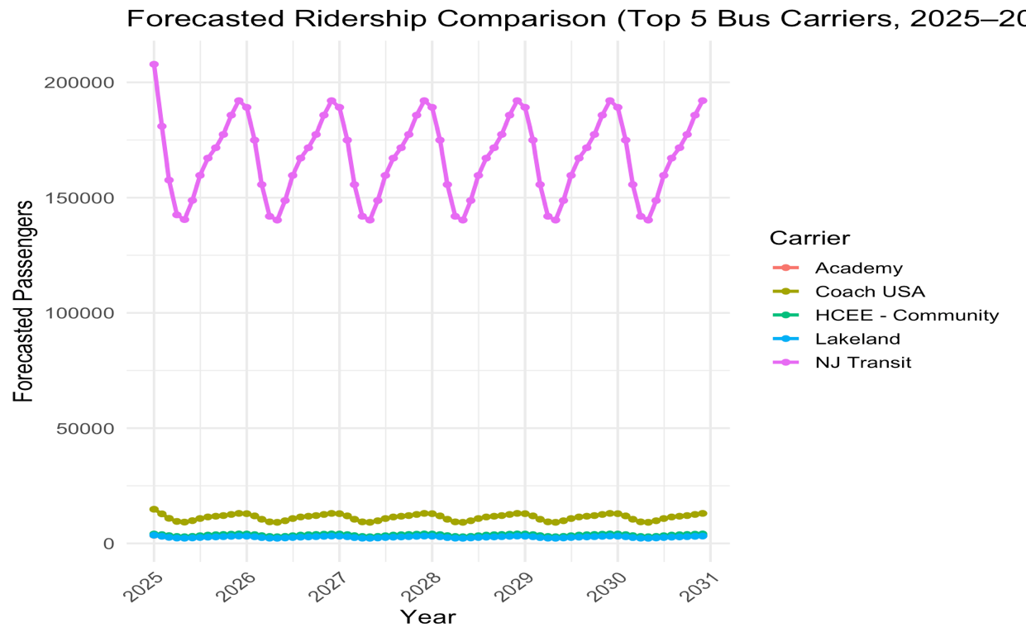
FORCASTED
- CODES:
# Forecast horizon in months for each carrier
forecast_h = map_int(data, ~{
last_month <- max(.x$YearMonth)
future_end <- as.Date("2030-12-01")
length(seq(from = last_month %m+% months(1),
to = future_end,
by = "month"))}),
# Forecast object
arima_fc = map2(arima_fit, forecast_h, ~forecast(.x, h = .y)))
# 4. Turn forecasts into one dataframe: CARRIER × YearMonth × Forecast_Passengers
carrier_forecasts <- carrier_models %>%
mutate(
forecast_tbl = pmap(
list(CARRIER, data, arima_fc),
function(carrier_name, df_carrier, fc_obj) {
last_month <- max(df_carrier$YearMonth)
h <- length(fc_obj$mean)
tibble(
CARRIER = carrier_name,
YearMonth = seq(from = last_month %m+% months(1),
by = "month",
length.out = h),
Forecast_Passengers = as.numeric(fc_obj$mean))})) %>%
select(CARRIER, forecast_tbl) %>%
unnest(cols = c(forecast_tbl))
# View head
head(carrier_forecasts)

# OPTIONAL EXAMPLE PLOT FOR ONE CARRIER
example_carrier <- "Greyhound"
carrier_example_actual <- carrier_monthly %>%
filter(CARRIER == example_carrier)
carrier_example_fc <- carrier_forecasts %>%
filter(CARRIER == example_carrier)
ggplot() +
geom_line(data = carrier_example_actual,
aes(x = YearMonth,
y = PASSENGERS,
color = "Actual")) +
geom_line (data = carrier_example_fc,
aes (x = YearMonth,
y = Forecast_Passengers,
color = "Forecast")) +
scale_x_date(date_breaks = "1 year", date_labels = "%Y") +
labs(title = paste("Monthly Passengers for", example_carrier,
"- Actual & forecast till 2030"),
x = "Year",
y = "Passengers",
color = "") +
theme_minimal()
ggplot(data, aes(x = YearMonth, y = Passengers, color = Type)) +
geom_line() +
scale_x_date(date_breaks = "1 year", date_labels = "%Y") +
labs(
title = paste("Monthly Passengers for", example_carrier,
"- Actual & Forecast till 2030"),
x = "Year",
y = "Passengers",
color = ""
) +
theme_minimal()

- INTERPRETATION: The forecast shows NJ Transit continuing to dominate ridership, fluctuating seasonally between ~140,000 and ~190,000 passengers per month. Coach USA follows far behind at roughly 8,000–14,000, while Academy, HCEE-Community, and Lakeland remain much smaller, generally below 5,000 passengers per month. Overall, all carriers show stable, repeating seasonal patterns with no major long-term growth or decline through 2030.

- Busiest times for the bus terminal staging facilities: Outcome, codes and interpretation.
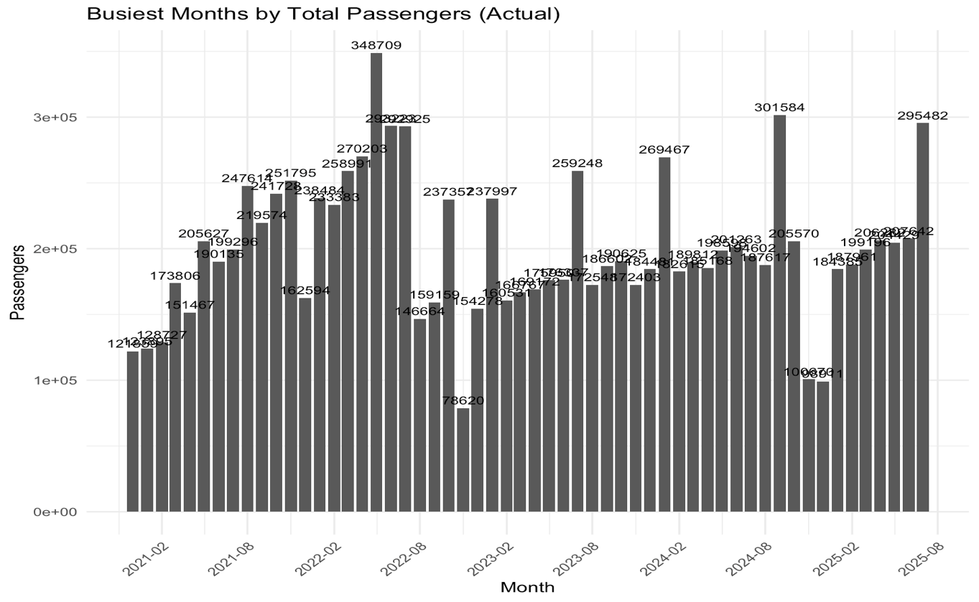

- CODES:
# 1. Busiest individual days (top 10)
busiest_days <- daily_totals %>%
arrange(desc(PASSENGERS)) %>%
slice_head(n = 10)

busiest_days

# 2. Busiest months (all carriers combined)
busiest_months <- pabt_actual %>%
mutate(YearMonth = floor_date(START_DATE, "month")) %>%
group_by(YearMonth) %>%
summarise(Total_Passengers = sum(PASSENGERS, na.rm = TRUE)) %>%
arrange(desc(Total_Passengers))

busiest_months

# 3. Busiest years
busiest_years <- pabt_actual %>%
group_by(YEAR) %>%
summarise(Total_Passengers = sum(PASSENGERS, na.rm = TRUE)) %>%
arrange(desc(Total_Passengers))

busiest_years

# 4. Weekday pattern (average passengers by day of week)
weekday_pattern <- daily_totals %>%
group_by(Weekday) %>%
summarise(Avg_Passengers = mean(PASSENGERS, na.rm = TRUE)) %>%
arrange(desc(Avg_Passengers))

weekday_pattern

# 5. Example visual for busiest months with number labels
ggplot(busiest_months,
aes(x = YearMonth, y = Total_Passengers)) +
geom_col() +
geom_text(aes(label = round(Total_Passengers, 0)),
vjust = -0.5,
size = 3) +
scale_x_date(date_breaks = "6 months",
date_labels = "%Y-%m") +
labs(title = "Busiest Months by Total Passengers (Actual)",
x = "Month",
y = "Passengers") +
theme_minimal() +
theme(axis.text.x = element_text(angle = 45, hjust = 1))

- INTERPRETATION: The busiest month occurs in mid-2022, with a peak of about 348,700 passengers. Other high-demand months generally fall between ~260,000 and ~300,000 passengers, often during late spring and summer. In contrast, the lowest months drop to around 80,000–110,000 passengers, showing strong seasonal variation in ridership.

